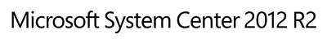

Guide for System Center Management Pack for HDInsight
Microsoft Corporation
Published: July 2014
Send feedback or suggestions about this document to mpgfeed@microsoft.com. Please include the management pack guide name with your feedback.
The Operations Manager team encourages you to provide feedback on the management pack by providing a review on the management pack’s page in the Management Pack Catalog (http://go.microsoft.com/fwlink/?LinkID=82105).

Copyright
This document is provided "as-is". Information and views expressed in this document, including URL and other Internet Web site references, may change without notice.
Some examples depicted herein are provided for illustration only and are fictitious. No real association or connection is intended or should be inferred.
This document does not provide you with any legal rights to any intellectual property in any Microsoft product. You may copy and use this document for your internal, reference purposes. You may modify this document for your internal, reference purposes.
© 2014 Microsoft Corporation. All rights reserved.
Microsoft, Active Directory, Bing, BizTalk, Forefront, Hyper-V, Internet Explorer, JScript, SharePoint, Silverlight, SQL Database, SQL Server, Visio, Visual Basic, Visual Studio, Win32, Windows, Windows Azure, Windows Intune, Windows PowerShell, Windows Server, and Windows Vista are trademarks of the Microsoft group of companies. All other trademarks are property of their respective owners.

Contents

Guide for System Center Management Pack for HDInsight 1
Copyright 2
Contents 3
Guide for System Center Management Pack for HDInsight 5
Guide History 5
Supported Configurations 5
Management Pack Scope 6
Before You Begin 7
Prerequisites 7
Files in this Management Pack 7
Management Pack Purpose 8
Monitoring Scenarios 8
How Health Rolls Up 13
Configuring the Management Pack for HDInsight 14
Mandatory Configuration 14
Optional Configuration 20
Best Practice: Create a Management Pack for Customizations 22
Links 26
Appendix: Management Pack Contents 27
HDInsight Ambari Service 27
HDInsight Cluster 28
HDInsight Clusters 29
HDInsight Cloud Service Clusters 30
HDInsight Cluster Software Projection 30
HDInsight Cluster Hardware Projection 31
HDInsight Host 32
HDInsight HDFS Cluster Service 32
HDInsight MapReduce Cluster Service 36
HDInsight Yarn Cluster Service 42
HDInsight Hive Cluster Service 46
HDInsight WebHCat Cluster Service 47
HDInsight Oozie Cluster Service 48
HDInsight Pig Cluster Service 49
HDInsight Sqoop Cluster Service 49
HDInsight Basic Performance Host Component 50
HDInsight Head Node Component 52
HDInsight NameNode Component 54
HDInsight Secondary NameNode Component 56
HDInsight JobTracker Component 57
HDInsight History Server Component 58
HDInsight DataNode Component 59
HDInsight TaskTracker Component 62
HDInsight ResourceManager Component 65
HDInsight NodeManager Component 66
HDInsight Hive Server Component 69
HDInsight Hive Metastore Component 70
HDInsight Hive Client Component 71
HDInsight WebHCat Server Component 72
HDInsight Oozie Server Component 73
HDInsight Pig Component 74
HDInsight Sqoop Component 75

Guide for System Center Management Pack for HDInsight
This guide was written based on version 1.0.200.0 of the Management Pack for HDInsight.

Guide History

Release Date | Changes
3/2014 | Original release of this guide,
7/2014 | Document update incorporating changes related to 1.0.200.0 Management Pack for HDInsight.

Supported Configurations
This management pack requires System Center Operations Manager 2012 or later. A dedicated Operations Manager management group is not required.
Management pack supports monitoring of HDInsight Appliance and HDInsight Service, although Service monitoring is limited.
The following table details the supported configurations for the Management Pack for HDInsight:

Configuration | Support
HDInsight Appliance | Microsoft Analytics Platform System (APS) AU1 and AU2.
HDInsight Azure Service | HDInsight 1.6, 2.1, 3.0 and 3.1.
Agentless monitoring | Supported by design.

Management Pack Scope
This management pack supports up to 100 Hadoop nodes per monitoring agent (watcher node). However, if you have cluster of more than 50 nodes it is recommended to spread monitoring across different agents. Please, refer to Using the Microsoft HDInsight Template section below for more information on how to do this.

Before You Begin

Prerequisites
The following requirements must be met to run this management pack:
- You need to have System Center Operations Manager 2012 or higher installed.
- HDInsight cluster with Ambari endpoint enabled.

Ambari is HDInsight API that management pack interacts with to perform all monitoring and management activities. It should be accessible at all times to enable cluster monitoring with this management pack.
If you use HDInsight on Analytics Platform System make sure that firewall rule “Client access to HDInsight cluster services (SSL encrypted)” is enabled in Configuration Manager.
If you use HDInsight on Azure, make sure that access to HDInsight services is enabled.
If you used version 1.0.100.0 of the Management Pack for HDInsight, you should follow the standard installation procedure to update it to version 1.0.200.0:
- Run HDInsightMP.msi to extract .mpb files to a desired location
- Import new version by running “Import Management Packs” wizard from Administration tab of Operations Console.

Files in this Management Pack
The Management Pack for HDInsight includes the following files:
- Microsoft.HDInsight.mpb
Required. Provides discovery and monitoring capabilities.
- Microsoft.HDInsight.Presentation.mpb
Required. Contains most of the monitoring dashboards, representing the state of HDInsight clusters.
- Microsoft.HDInsight.Management.mpb
Optional. Management tasks are not supported for HDInsight Service, thus you do not need to import this management pack if monitoring the Service is your only goal.

Management Pack Purpose
HDInsight management pack discovers and monitors HDInsight cluster instances and their components.
In this section you can find more about:
• Monitoring Scenarios
• How Health Rolls Up
For details on the discoveries, rules, monitors, views, and reports contained in this Management pack, see Appendix: Management Pack Contents.

Monitoring Scenarios

Monitoring scenario | Description | Associated rules and monitors
DataNodes health state | This scenario monitors DataNodes health state. When significant amount of DataNodes are down – you will receive warning and critical alerts. | - (non-alerting rule) Collect HDFS Dead DataNodes  - (non-alerting rule) Collect HDFS Live DataNodes  - (alerting monitor) DataNodes Down  Generates warning and critical alerts based on specified threshold in percent.
NameNode Safe Mode | This scenario monitors if NameNode operates in safe mode. This is a mode of HDFS when read-only access to file system is allowed, which significantly reduces usability of the cluster. | - (alerting monitor) Operational Mode  Generates warning alert when NameNode is operating in safe mode.
HDFS remaining capacity | This scenario monitors amount of available space in HDFS cluster. When space is running low – warning and critical alerts will be raised. | - (non-alerting rule) Collect HDFS Capacity Total (GB)  - (non-alerting rule) Collect HDFS Capacity Used (GB)  - (non-alerting rule) Collect HDFS Capacity Non-DFS Used (GB)  - (non-alerting rule) Collect HDFS Capacity Remaining (GB)  - (alerting monitor) Capacity Remaining  Generates warning and critical alerts based on specified thresholds in percent.
Corrupted HDFS blocks | This scenario monitors number of corrupted blocks in the HDFS. When significant number of blocks are corrupted – critical alert is raised. | - (non-alerting rule) Collect HDFS Corrupted Blocks  - (alerting monitor) Corrupted Blocks  Generates critical alert based on specified threshold.
Under-replicated HDFS blocks | This scenario monitors number of under-replicated blocks in HDFS. When significant number of blocks are under-replicated – you will receive warning and critical alerts. | - (non-alerting rule) Collect HDFS Under-Replicated Blocks  - (alerting monitor) Under-Replicated Blocks  Generates warning and critical alerts based on specified thresholds.
TaskTrackers health state | This scenario monitors TaskTrackers health state. When significant number of TaskTrackers are down – you will receive warning and critical alerts. | - (non-alerting rule) Collect MapReduce Dead TaskTrackers  - (non-alerting rule) Collect MapReduce Live TaskTrackers  - (alerting monitor) TaskTrackers Down  Generates warning and critical alerts based on specified threshold in percent.
Invalid (graylisted and blacklisted) TaskTrackers | This scenario checks existence of graylisted and blacklisted TaskTrackers. When they present – alert is raised. | - (non-alerting rule) Collect MapReduce TaskTrackers Graylisted  - (non-alerting rule) Collect MapReduce TaskTrackers Blacklisted  - (alerting monitor) Invalid TaskTrackers  Generates warning and critical alerts based on configuration.
MapReduce jobs | This scenario monitors number of submitted, preparing, running, completed, killed and failed MapReduce jobs. When significant number of submitted jobs are failing – you will receive warning and critical alerts. | - (non-alerting rule) Collect MapReduce Jobs Submitted  - (non-alerting rule) Collect MapReduce Jobs Preparing  - (non-alerting rule) Collect MapReduce Jobs Running  - (non-alerting rule) Collect MapReduce Jobs Completed  - (non-alerting rule) Collect MapReduce Jobs Killed  - (non-alerting rule) Collect MapReduce Jobs Failed  - (alerting monitor) Failed Jobs  Generates warning and critical alerts base on specified threshold in percent.
Yarn applications | This scenario monitors number of submitted, running, completed, killed and failed Yarn applications. When significant number of submitted applications are failing – you will receive warning and critical alerts. | - (non-alerting rule) Collect Yarn Apps Submitted  - (non-alerting rule) Collect Yarn Apps Running  - (non-alerting rule) Collect Yarn Apps Completed  - (non-alerting rule) Collect Yarn Apps Killed  - (non-alerting rule) Collect Yarn Apps Failed  - (alerting monitor) Failed Applications  - Generates warning and critical alerts base on specified threshold in percent.
Ambari service accessibility | This scenario monitors accessibility of Ambari service by executing synthetic transactions. Whenever service is unavailable because of wrong URL, invalid credentials or due to any transient server issue – critical alert is raised. | - (alerting monitor) Ambari API Credentials  Generates critical alert when server returns 401 (Unauthorized) or 403 (Forbidden) response.  - (alerting monitor) Ambari API URL Check  Generates critical alert when name resolution fails or server returns 404 (Not Found) response.  - (alerting monitor) Ambari API Availability  Generates critical alert when connection to server cannot be established or server returns 503 (Service Unavailable) response.
NameNode, JobTracker and ResourceManager memory heap usage | This scenario checks memory usage of NameNode, JobTracker and ResourceManager processes. When memory usage is close to the committed amount – warning or critical alert is raised. | - (non-alerting rule) Collect JVM Memory Heap Used (MB)  - (non-alerting rule) Collect JVM Memory Heap Committed (MB)  - (alerting monitor) Memory Heap Usage  Generates warning and critical alerts based on specified thresholds in percent.
Host Components health state (not available for HDInsight Service) | This scenario checks health state of all host components. Whenever host component is not running – alert is raised. | - (alerting monitor) NameNode Service State  - (alerting monitor) Secondary NameNode Service State  - (alerting monitor) DataNode Service State  - (alerting monitor) JobTracker Service State  - (alerting monitor) History Server Service State  - (alerting monitor) TaskTracker Service State  - (alerting monitor) ResourceManager Service State  - (alerting monitor) NodeManager Service State  - (alerting monitor) Hive Server Service State  - (alerting monitor) Hive Metastore Service State  - (alerting monitor) Oozie Server Service State  - (alerting monitor) Templeton/WebHCat Server Service State  Generates critical alerts when target host component is not in the Running state.

How Health Rolls Up
The following diagram shows how the health states of objects roll up in this management pack.
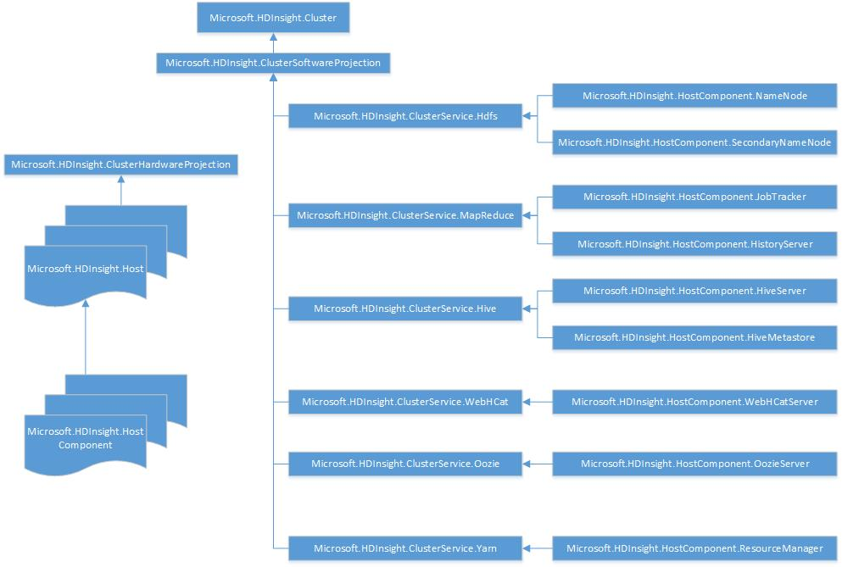

Configuring the Management Pack for HDInsight

Mandatory Configuration
To start monitoring your HDInsight cluster you have to:
- Configure Certificate
- Setup run-as profiles

Certificate Configuration
Ambari is accessible over HTTPS only, thus every HDInsight cluster should be configured with a certificate.
HDInsight on Azure will use certificate issued by well-known certificate authority (CA), while customers of Analytics Platform System appliance can specify any certificate using “Import certificate” option from Configuration Manager.
Although, it is recommended to use valid certificates, Appliance administrator might use a self-signed certificate. If you use custom certificate, you will need to configure every watcher node to trust this certificate.
To do this, follow these steps:
- Obtain correct certificate from Appliance administrator.
Important
Please note, that certificate subject name should correspond to the Appliance network address, otherwise you won’t be able to monitor it even after following these steps.
- For every Management Server in the resource pool, selected as Watcher Nodes pool during HDInsight monitoring wizard setup
- Import the certificate to certificate store:
  - Open Run and type “mmc” to open Microsoft Management Console.
  - In File menu, select Add/Remove Snap-in…
  - Select Certificates and click Add.
  - In the Certificates snap-in window, select Computer account and click Next.
  - In the Select Computer window, select Local computer and click Finish.
  - Click OK in the Add or Remove Snap-ins window.
  - In the snap-ins tree, navigate to Console Root | Certificates (Local computer) | Trusted Root Certification Authorities | Certificates , right-click the Certificates node and select All tasks | Import…
  - Follow the wizard steps to import certificate.

Security Configuration

Run As Profile Name | Associated Rules and Monitors | Notes
HDInsight Workflow Account | All | This is the default account to execute all management pack workflows. It is used to execute all the scripts and process events log for self-monitoring.
HDInsight Ambari Credentials | All rules accessing Ambari REST API. | This account is mapped to simple or basic authentication profile containing Ambari credentials.

Using the Microsoft HDInsight Template
To setup HDInsight cluster monitoring:
- In SCOM Console navigate to Authoring | Management Pack Templates | Microsoft HDInsight, right-click it and select Add Monitoring Wizard…:

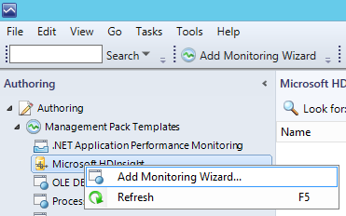

- On the Monitoring Type page select Microsoft HDInsight and click Next:

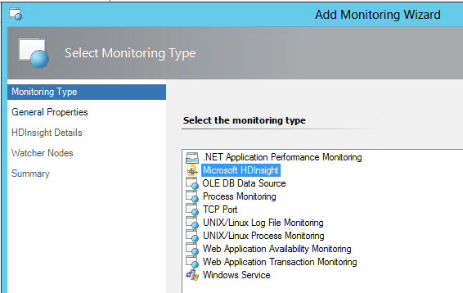

- On the General Properties page provide Name and Description for your HDInsight cluster and select target Management Pack to store configuration to:

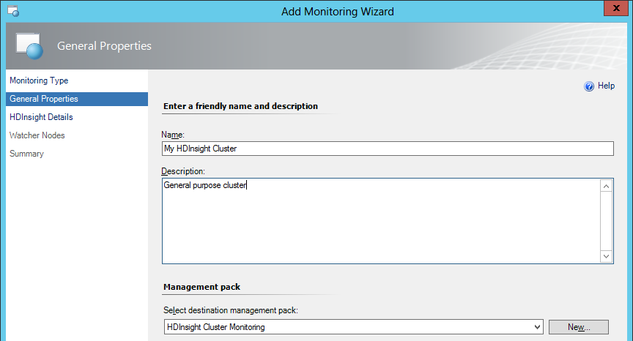
For more information about target Management Pack, please see Best Practice: Create a Management Pack for Customizations section. You can create new management pack right from this wizard by clicking New button, located next to Management Packs drop-down list.

- On the HDInsight Details page provide your Ambari URI and Credentials Run As Account to be used:

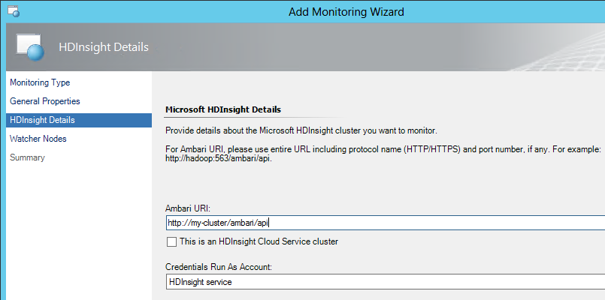
If you are setting up monitoring for HDInsight Cloud service, select This is an HDInsight Cloud Service cluster option.

- On the Watcher Nodes page you need to specify the resource pool that will be used for remote monitoring. To do this:
  - Click Browse button next to Resource Pool:
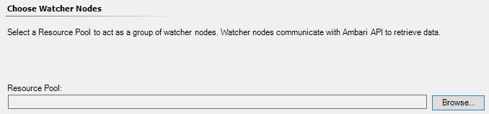

  - In the Select Resource Pool dialog enter search criteria (or leave textbox empty to show all available agents) and click Search:
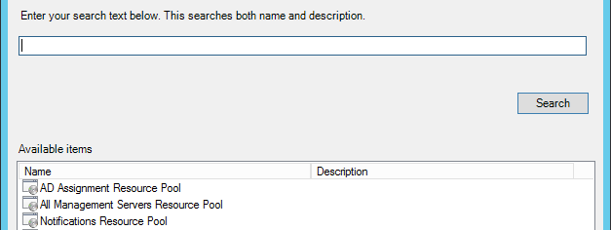

  - Select desired resource pool and click OK. Selected pool will show up on Watcher Nodes page. Click Next.

  - If selected Run As Account (step 4) uses More Secure distribution model, you will need to allow distribution to the selected resource pool. If it is not allowed yet, you will be prompted to do so.
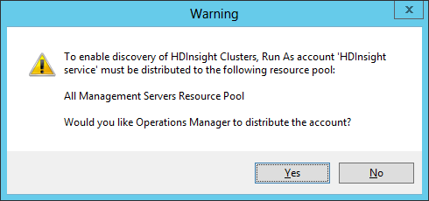

- Review the configuration on the Summary page and click Create:

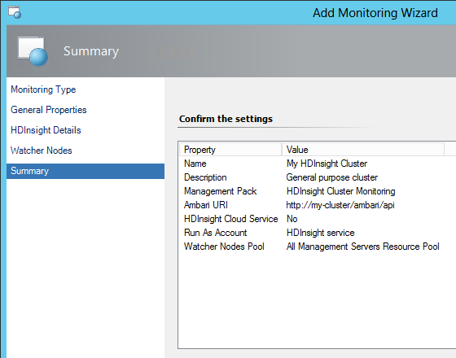

Optional Configuration

Configure E-mail Alert Notifications
SCOM provides ability to send an email message to the IT administrators when the state of the appliance changes. In order to configure email alert notifications one should:
- Create SMTP channel
- Create subscribers
- Create subscription

Creating SMTP channel
To configure notifications, SCOM Administrator should create SMTP channel first.
To do this:
- In SCOM Console, navigate to the Administration tab, right-click Notifications and select New Channel | E-Mail (SNMP)…
- On the Description page, type the Channel Name and Description.
- On the Settings page, add SMTP server and type in the Return address.
- On the Format page, enter the following in E-mail subject:
Alert: $Data/Context/DataItem/AlertName$ Resolution state: $Data/Context/DataItem/ResolutionStateName$

- On the Format page, enter the E-mail message as follows:

Alert: $Data/Context/DataItem/AlertName$

Last modified by: $Data/Context/DataItem/LastModifiedBy$

Last modified time: $Data/Context/DataItem/LastModifiedLocal$

Alert description:
$Data/Context/DataItem/AlertDescription$

Alert view link: "$Target/Property[Type="Notification!Microsoft.SystemCenter.AlertNotificationSubscriptionServer"]/WebConsoleUrl$?DisplayMode=Pivot&AlertID=$UrlEncodeData/Context/DataItem/AlertId$"
Notification subscription ID generating this message: $MPElement$

- Click Finish.

Creating subscribers
After channel is created, it’s necessary to add subscribers which can then be used to receive notifications.
To do this:
- On the Administration tab, right-click Notifications and select New subscriber…
- On the Description page type in Subscriber Name
- On the Schedule page select if you want this subscriber to always get notifications or only during specified times.
- On the Addresses page click Add…
  - New Subscriber Address dialog will pop-up
  - On the General page specify the Address name for the new address
  - On the Channel page select “E-Mail (SMTP)” as Channel Type and type in actual email address for this subscriber (Delivery address for the selected channel).
  - On the Schedule page select if you want this subscriber to always get notifications or only during specified times.
  - Click Finish
- Click Finish

Creating subscription
To create a subscription, do the following:
- On the Administration tab, right-click Notifications and select New subscription…
- On the Description page provide name and description for a new subscription.
- On the Criteria page specify the conditions on which notifications should be generated. For more information on how to configure notifications for specific appliance instance see next section.
- On the Subscribers page click Add… to add previously created subscribers. For more information on how to create subscribers see “Creating subscribers” section.
- On the Channels page click Add… to add previously created SMTP channel. For more information on how to create SMTP channel see “Creating SMTP channel” section.
- On the Summary page check whether everything is correct and select Enable this notification subscription checkbox.
- Click Finish.

Configuring email notifications for specific appliance instance
First, one should create a group with all alerting components of HDInsight Appliance. For doing this:
- On the Authoring tab, right-click Groups and select Create a new group…
- In Create Group Wizard:
  - On the General Properties page specify name and description for a new group. It’s recommended to use something meaningful, like “<Appliance name> alerting components”. In addition it’s required to specify target management pack where group information will be stored. It’s recommended to use special MP for such purpose. For more information see “Best Practice: Create a Management Pack for Customizations” section.
  - On the Dynamic Members page click Create/Edit rules…
  - Add “HDInsight Cluster Service” to the list and specify “Cluster Name - Equals - <Desired Appliance Name>” rule.
  - Add “HDInsight Host Component” to the list and specify “Cluster Name - Equals - <Desired Appliance Name>” rule.
  - Select the Excluded Members page and click Create.
After group with alerting components of the Appliance has been created it’s now possible to use it in notification subscription criteria. For more information on how to create a subscription, see “Creating subscription” section. To add additional criteria to the subscription:
- Right-click existing subscription and click Properties.
- On the Criteria page check “raised by any instance in a specific group” condition and specify newly created group of alerting components for desired appliance.
- Select the Summary page and click Finish.
Now your subscription will only monitor alerts from desired appliance instance.

Best Practice: Create a Management Pack for Customizations
By default, Operations Manager saves all customizations such as overrides to the Default Management Pack. As a best practice, you should instead create a separate management pack for each sealed management pack you want to customize.
When you create a management pack for the purpose of storing customized settings for a sealed management pack, it is helpful to base the name of the new management pack on the name of the management pack that it is customizing.
Creating a new management pack for storing customizations of each sealed management pack makes it easier to export the customizations from a test environment to a production environment. It also makes it easier to delete a management pack, because you must delete any dependencies before you can delete a management pack. If customizations for all management packs are saved in the Default Management Pack and you need to delete a single management pack, you must first delete the Default Management Pack, which also deletes customizations to other management packs.

Performance Threshold Monitors
The following table lists performance threshold monitors that have default thresholds that might require additional tuning to suit your environment. Evaluate these rules to determine whether the default thresholds are appropriate for your environment. If a default threshold is not appropriate for your environment, you should obtain a baseline for the relevant performance counters, and then adjust the thresholds by applying an override to them.

Context | Monitor Name | Warning Threshold | Critical Threshold
HDFS Service | Capacity Remaining | 30% | 10%
 | DataNodes Down | > 0% | 25%
 | Corrupted Blocks | – | 1
 | Under-Replicated Blocks | 1% | 5%
MapReduce Service | TaskTrackers Down | > 0% | 25%
 | Invalid TaskTrackers | 1 graylisted | 1 blacklisted
 | Failed Jobs | 10% | 40%
Yarn Service | NodeManagers Down | > 0% | 25%
 | Invalid NodeManagers | 1 lost | 1 unhealthy
 | Failed Applications | 10% | 40%
NameNode | Memory Heap Usage | 85% | 95%
JobTracker | Memory Heap Usage | 85% | 95%
Resource Manager | Memory Heap Usage | 85% | 95%

Overriding Threshold Monitors
If you need to override monitor thresholds to adjust them to your environment, use the following procedure:
- In SCOM Console, navigate to Authoring | Management Pack Objects | Monitors.
- Use Look for search box to quickly locate monitor that you would like to override:
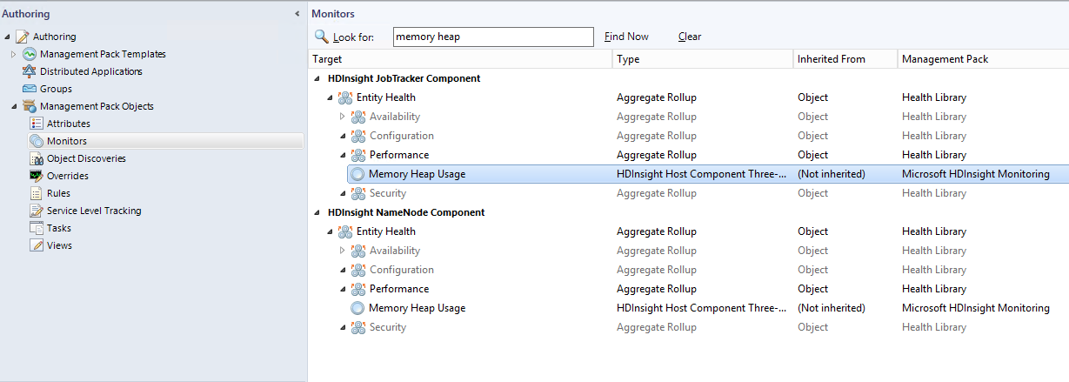

- Right-click the monitor and select Properties in the context menu
- To change monitor configuration, navigate to the Overrides tab and click Override button.
- Carefully choose the scope of override operation. One of safe choices is “For a specific object of class: <class name>”. In this example this option would be presented as “For a specific object of class: HDInsight JobTracker Component”
- Select object that match this criteria (HDInsight cluster(s) which monitor you would like to override)
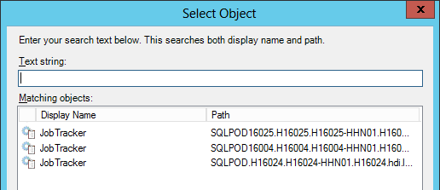

- Select option(s) that you want to override: Warning Threshold and Critical Threshold. Enter new value in Override Value column and click Apply (or OK if you want to finish with overrides).
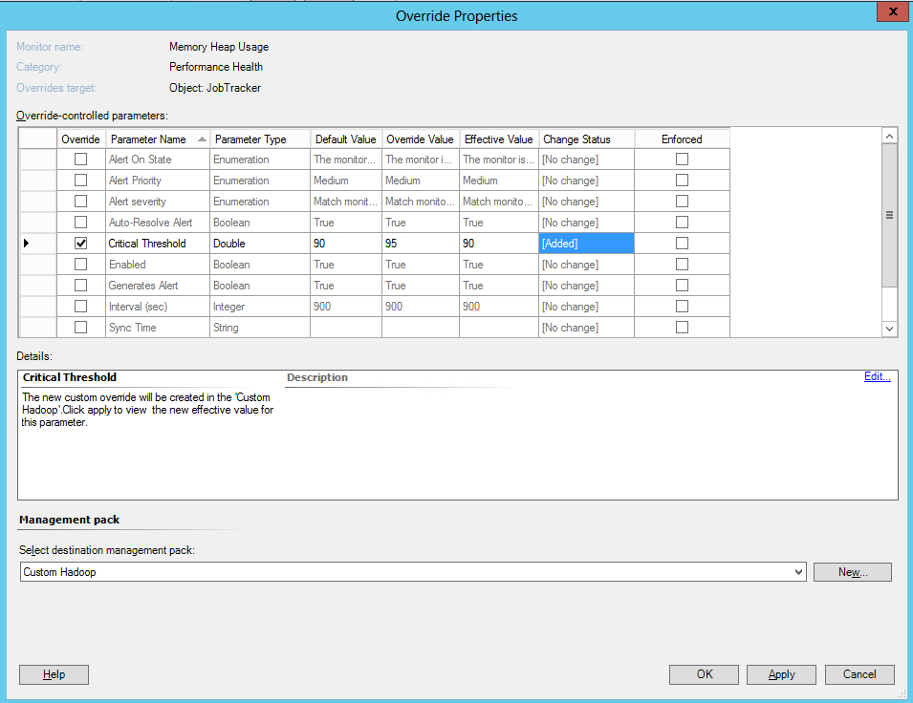

Links
The following links connect you to information about common tasks that are associated with System Center management packs:
- Management Pack Life Cycle
- How to Import a Management Pack
- Tuning Monitoring by Using Targeting and Overrides
- How to Create a Run As Account
- How to Create a Resource Pool
- How to Export a Management Pack
- How to Remove a Management Pack
For questions about Operations Manager and management packs, see the System Center Operations Manager community forum.
A useful resource is the System Center Operations Manager Unleashed blog, which contains “By Example” posts for specific management packs.
For additional information about Operations Manager, see the System Center 2012 - Operations Manager Survival Guide and Operations Manager 2007 Management Pack and Report Authoring Resources
Important
All information and content on non-Microsoft sites is provided by the owner or the users of the website. Microsoft makes no warranties, express, implied, or statutory, as to the information at this website.

Appendix: Management Pack Contents
The Management Pack for HDInsight discovers the object types described in the following sections. Not all of the objects are automatically discovered. Use monitoring template to discover those objects that are not discovered automatically.

HDInsight Ambari Service
This class represents HDInsight Ambari Service.
Discovery Information
Interval | Enabled | When to Enable
14400 | Monitoring template | N/A

Related Monitors
Monitor | Data source | Interval | Alert | Reset Behavior | Corresponding Rule | Enabled | When to Enable
Ambari API Credentials | HDInsight API Synthetic Transaction Data Provider | 900 | True  Alert priority: Normal  Alert severity: Error | Automatic | None | True | N/A
Ambari API URL Check | HDInsight API Synthetic Transaction Data Provider | 900 | True  Alert priority: Normal  Alert severity: Error | Automatic | None | True | N/A
Ambari API Availability | HDInsight API Synthetic Transaction Data Provider | 900 | True  Alert priority: Normal  Alert severity: Error | Automatic | None | True | N/A

Related Rules
There are no rules associated with this discovery.
Related Views
There are no views associated with this discovery.
Related Reports
There are no reports associated with this discovery.

HDInsight Cluster
Discovery Information
Interval | Enabled | When to Enable
14400 | True | N/A

Related Monitors
There are no monitors associated with this discovery.
Related Rules
There are no rules associated with this discovery.
Related Views
View | Description | Rules and Monitors that Populate the View
Clusters Diagram | This diagram view shows topology of all HDInsight Clusters being monitored. | - HDInsight Clusters Discovery  - HDInsight Cluster Services Discovery  - HDInsight Host Components Discovery  Monitors:  - Capacity Remaining (HDFS service)  - Corrupted Blocks (HDFS service)  - DataNodes Down (HDFS service)  - Under-Replicated Blocks (HDFS service)  - Failed Jobs (MapReduce service)  - Invalid TaskTrackers (MapReduce service)  - TaskTrackers Down (MapReduce service)  - DataNode Component State  - History Server Component State  - Hive Metastore Component State  - Hive Server Component State  - JobTracker Component State  - NameNode Component State  - Oozie Server Component State  - Secondary NameNode Component State  - TaskTracker Component State  - WebHCat Server Component State  - Memory Heap Usage (NameNode component)  - Operational Mode (NameNode component)  - Memory Heap Usage (JobTracker component)
Cluster Summary | This dashboard shows high-level overview of HDInsight Clusters state.

Related Reports
There are no reports associated with this discovery.

HDInsight Clusters
Discovery Information
Interval | Enabled | When to Enable
N/A (Group population) | True | N/A

Related Monitors
There are no monitors associated with this discovery.
Related Rules
There are no rules associated with this discovery.
Related Views
View | Description | Rules and Monitors that Populate the View
Clusters Diagram | This diagram view shows topology of all HDInsight Clusters being monitored. | - HDInsight Clusters Group Discovery
Related Reports
There are no reports associated with this discovery.

HDInsight Cloud Service Clusters
Discovery Information
Interval | Enabled | When to Enable
N/A (Group population) | True | N/A

Related Monitors
There are no monitors associated with this discovery.
Related Rules
There are no rules associated with this discovery.
Related Views
There are no views associated with this discovery.
Related Reports
There are no reports associated with this discovery.

HDInsight Cluster Software Projection
Discovery Information
Interval | Enabled | When to Enable
14400 | True | N/A

Related Monitors
There are no monitors associated with this discovery.
Related Rules
There are no rules associated with this discovery.
Related Views
View | Description | Rules and Monitors that Populate the View
Clusters Diagram | This diagram view shows topology of all HDInsight Clusters being monitored. | - HDInsight Clusters Discovery

Related Reports
There are no reports associated with this discovery.

HDInsight Cluster Hardware Projection
Discovery Information
Interval | Enabled | When to Enable
14400 | True | N/A

Related Monitors
There are no monitors associated with this discovery.
Related Rules
There are no rules associated with this discovery.
Related Views
View | Description | Rules and Monitors that Populate the View
Clusters Diagram | This diagram view shows topology of all HDInsight Clusters being monitored. | - HDInsight Clusters Discovery

Related Reports
There are no reports associated with this discovery.

HDInsight Host
Discovery Information
Interval | Enabled | When to Enable
14400 | True | N/A

Related Monitors
There are no monitors associated with this discovery.
Related Rules
There are no rules associated with this discovery.
Related Views
View | Description | Rules and Monitors that Populate the View
Clusters Diagram | This diagram view shows topology of all HDInsight Clusters being monitored. | - HDInsight Hosts Discovery
Related Reports
There are no reports associated with this discovery.

HDInsight HDFS Cluster Service
Discovery Information
Interval | Enabled | When to Enable
14400 | True | N/A
Related Monitors
Monitor | Data source | Interval | Alert | Reset Behavior | Corresponding Rule | Enabled | When to Enable
Capacity Remaining | HDInsight HDFS Cluster Service Metrics Property Bag Data Provider | 900 | True  Alert priority: Normal  Alert severity: <30% - Warning, <10% - Error | Automatic | None | True | N/A
Corrupted Blocks |  | 900 | True  Alert priority: Normal  Alert severity: Error | Automatic | None | True | N/A
DataNodes Down |  | 900 | True  Alert priority: Normal  Alert severity: >0% - Warning, >25% - Error | Automatic | None | True | N/A
Under-Replicated Blocks |  | 900 | True  Alert priority: Normal  Alert severity: >1 - Warning, >5 - Error | Automatic | None | True | N/A
Related Rules
Rule | Data source | Alert | Notes | Corresponding Monitor | Enabled | When to Enable
Collect HDFS Capacity Non-DFS Used (GB) | HDInsight HDFS Cluster Service Metrics Performance Data Provider | False | Collects Non-DFS used capacity in gigabytes. | None | True | N/A
Collect HDFS Capacity Remaining (GB) |  | False | Collects remaining HDFS capacity in gigabytes. | None | True | N/A
Collect HDFS Capacity Total (GB) |  | False | Collects total HDFS capacity in gigabytes. | None | True | N/A
Collect HDFS Capacity Used (GB) |  | False | Collects used HDFS capacity in gigabytes. | None | True | N/A
Collect HDFS Corrupted Blocks |  | False | Collects number of corrupted HDFS blocks. | None | True | N/A
Collect HDFS Dead DataNodes |  | False | Collects number of dead DataNodes. | None | True | N/A
Collect HDFS Live DataNodes |  | False | Collects number of live DataNodes. | None | True | N/A
Collect HDFS Decommissioned DataNodes |  | False | Collects number of decommissioned DataNodes. | None | True | N/A
Collect HDFS Files Appended |  | False | Collects number of files appended in the HDFS. | None | True | N/A
Collect HDFS Files Created |  | False | Collects number of files created in the HDFS. | None | True | N/A
Collect HDFS Files Deleted |  | False | Collects number of files deleted from the HDFS. | None | True | N/A
Collect HDFS Missing Blocks |  | False | Collects number of missing HDFS blocks. | None | True | N/A
Collect HDFS Pending Deletion Blocks |  | False | Collect number of HDFS blocks pending deletion. | None | True | N/A
Collect HDFS Pending Replication Blocks |  | False | Collects number of HDFS blocks pending replication. | None | True | N/A
Collect HDFS Total Blocks |  | False | Collects total number of HDFS blocks. | None | True | N/A
Collect HDFS Total Data Read (TB) |  | False | Collects amount of data read from HDFS. | None | True | N/A
Collect HDFS Total Data Written (TB) |  | False | Collects amount of data written to HDFS. | None | True | N/A
Collect HDFS Total Files |  | False | Collects total number of files stored in the HDFS. | None | True | N/A
Collect HDFS Under-Replicated Blocks |  | False | Collects number of under-replicated HDFS blocks. | None | True | N/A
Related Views
View | Description | Rules and Monitors that Populate the View
Clusters Diagram | This diagram view shows topology of all HDInsight Clusters being monitored. | - HDInsight Cluster Services Discovery  - Capacity Remaining  - Corrupted Blocks  - DataNodes Down  - Under-Replicated Blocks
Cluster Summary | This dashboard shows high-level overview of HDInsight Clusters state.
HDFS Summary | This dashboard shows HDFS service state and performance. | - HDInsight Cluster Services Discovery  - Capacity Remaining  - Corrupted Blocks  - DataNodes Down  - Under-Replicated Blocks  - Collect HDFS Total Files  - Collect HDFS Files Created  - Collect HDFS Files Appended  - Collect HDFS Files Deleted  - Collect HDFS Total Blocks  - Collect HDFS Corrupted Blocks  - Collect HDFS Missing Blocks  - Collect HDFS Under-Replicated Blocks  - Collect HDFS Capacity Remaining (GB)  - Collect HDFS Total Data Read (TB)  - Collect HDFS Total Data Written (TB)
Cluster Services Performance | This performance view shows data collected for all cluster services. | All related rules.
Related Reports
There are no reports associated with this discovery.

HDInsight MapReduce Cluster Service
Discovery Information
Interval | Enabled | When to Enable
14400 | True | N/A
Related Monitors
Monitor | Data source | Interval | Alert | Reset Behavior | Corresponding Rule | Enabled | When to Enable
TaskTrackers Down | HDInsight MapReduce Cluster Service Metrics Property Bag Provider | 900 | True  Alert priority: Normal  Alert severity: >0% - Warning, >25% - Error | Automatic | None | True | N/A
Failed Jobs |  | 900 | True  Alert priority: Normal  Alert severity: >10% - Warning, >40% - Error | Automatic | None | True | N/A
Invalid TaskTrackers |  | 900 | True  Alert priority: Normal  Alert severity: graylisted >=1 - Warning, blacklisted >=1 - Error | Automatic | None | True | N/A
Related Rules
Rule | Data source | Alert | Notes | Corresponding Monitor | Enabled | When to Enable
Collect MapReduce Dead TaskTrackers | HDInsight MapReduce Cluster Service Metrics Performance Data Provider | False | Collects number of dead TaskTrackers. | None | True | N/A
Collect MapReduce Jobs Failed (%) |  | False | Collects percent of failed MapReduce jobs. | None | True | N/A
Collect MapReduce Jobs Completed |  | False | Collects number of completed MapReduce jobs. | None | True | N/A
Collect MapReduce Jobs Failed |  | False | Collects number of failed MapReduce jobs. | None | True | N/A
Collect MapReduce Jobs Killed |  | False | Collects number of killed MapReduce jobs. | None | True | N/A
Collect MapReduce Jobs Preparing |  | False | Collects number of preparing MapReduce jobs. | None | True | N/A
Collect MapReduce Jobs Running |  | False | Collects number of running MapReduce jobs. | None | True | N/A
Collect MapReduce Jobs Submitted |  | False | Collects number of submitted MapReduce jobs. | None | True | N/A
Collect MapReduce Live TaskTrackers |  | False | Collects number of live TaskTrackers. | None | True | N/A
Collect MapReduce Maps Completed |  | False | Collects number of completed map tasks. | None | True | N/A
Collect MapReduce Maps Failed |  | False | Collects number of failed map tasks. | None | True | N/A
Collect MapReduce Maps Killed |  | False | Collects number of killed map tasks. | None | True | N/A
Collect MapReduce Maps Launched |  | False | Collects number of launched map tasks. | None | True | N/A
Collect MapReduce Maps Running |  | False | Collects number of running map tasks. | None | True | N/A
Collect MapReduce Maps Waiting |  | False | Collects number of waiting map tasks. | None | True | N/A
Collect MapReduce Number of TaskTrackers |  | False | Collects total number of TaskTrackers. | None | True | N/A
Collect MapReduce Occupied Map Slots |  | False | Collects number of occupied map slots. | None | True | N/A
Collect MapReduce Occupied Reduce Slots |  | False | Collects number of occupied reduce slots. | None | True | N/A
Collect MapReduce Reduces Completed |  | False | Collects number of completed reduce tasks. | None | True | N/A
Collect MapReduce Reduces Failed |  | False | Collects number of failed reduce tasks. | None | True | N/A
Collect MapReduce Reduces Killed |  | False | Collects number of killed reduce tasks. | None | True | N/A
Collect MapReduce Reduces Launched |  | False | Collects number of launched reduce tasks. | None | True | N/A
Collect MapReduce Reduces Running |  | False | Collects number of running reduce tasks. | None | True | N/A
Collect MapReduce Reduces Waiting |  | False | Collects number of waiting reduce tasks. | None | True | N/A
Collect MapReduce Reserved Map Slots |  | False | Collects number of reserved map slots. | None | True | N/A
Collect MapReduce Reserved Reduce Slots |  | False | Collects number of reserved reduce slots. | None | True | N/A
Collect MapReduce TaskTrackers Blacklisted |  | False | Collects number of blacklisted TaskTrackers. | None | True | N/A
Collect MapReduce TaskTrackers Decommissioned |  | False | Collects number of decommissioned TaskTrackers. | None | True | N/A
Collect MapReduce TaskTrackers Graylisted |  | False | Collects number of graylisted TaskTrackers. | None | True | N/A
Related Views
View | Description | Rules and Monitors that Populate the View
Clusters Diagram | This diagram view shows topology of all HDInsight Clusters being monitored. | - HDInsight Cluster Services Discovery  - TaskTrackers Down  - Failed Jobs  - Invalid TaskTrackers
Cluster Summary | This dashboard shows high-level overview of HDInsight Clusters state.
MapReduce Summary | This dashboard shows MapReduce service state and performance. | - HDInsight Cluster Services Discovery  - TaskTrackers Down  - Failed Jobs  - Invalid TaskTrackers  - Collect MapReduce Jobs Submitted  - Collect MapReduce Jobs Completed  - Collect MapReduce Jobs Failed  - Collect MapReduce Jobs Killed  - Collect MapReduce Occupied Map Slots  - Collect MapReduce Occupied Reduce Slots  - Collect MapReduce Reserved Map Slots  - Collect MapReduce Reserved Reduce Slots  - Collect MapReduce Maps Running  - Collect MapReduce Reduces Running  - Collect MapReduce Number of TaskTrackers  - Collect MapReduce TaskTrackers Graylisted  - Collect MapReduce TaskTrackers Blacklisted  - Collect MapReduce TaskTrackers Decommissioned
Cluster Services Performance | This performance view shows data collected for all cluster services. | All related rules.
Related Reports
There are no reports associated with this discovery.

HDInsight Yarn Cluster Service
Discovery Information
Interval | Enabled | When to Enable
14400 | True | N/A
Related Monitors
Monitor | Data source | Interval | Alert | Reset Behavior | Corresponding Rule | Enabled | When to Enable
NodeManagers Down | HDInsight Yarn Cluster Service Metrics Property Bag Provider | 900 | True  Alert priority: Normal  Alert severity: >0% - Warning, >25% - Error | Automatic | None | True | N/A
Failed Applications |  | 900 | True  Alert priority: Normal  Alert severity: >10% - Warning, >40% - Error | Automatic | None | True | N/A
Invalid NodeManagers |  | 900 | True  Alert priority: Normal  Alert severity: NumLostNMs >=1 - Warning, NumUnhealthyNMs >=1 - Error | Automatic | None | True | N/A
Related Rules
Rule | Data source | Alert | Notes | Corresponding Monitor | Enabled | When to Enable
Collect Yarn Node Managers Unhealthy | HDInsight Yarn Cluster Service Metrics Performance Data Provider | False | Collects number of unhealthy Node Managers in HDInsight cluster. | None | True | N/A
Collect Yarn Node Managers Rebooted |  | False | Collects number of rebooted Node Managers in HDInsight cluster. | None | True | N/A
Collect Yarn Node Managers Lost |  | False | Collects number of lost Node Managers in HDInsight cluster. | None | True | N/A
Collect Yarn Node Managers Decommissioned |  | False | Collects number of decommissioned Node Managers in HDInsight cluster. | None | True | N/A
Collect Yarn Node Managers Active |  | False | Collects number of completed Node Managers in HDInsight cluster. | None | True | N/A
Collect Yarn Active Applications |  | False | Collects number of active Yarn applications in HDInsight cluster. | None | True | N/A
Collect Yarn Active Users |  | False | Collects number of active Yarn users in HDInsight cluster. | None | True | N/A
Collect Allocated Containers |  | False | Collects number of allocated containers. | None | True | N/A
Collect Allocated Memory |  | False | Collects number of allocated memory in MBs. | None | True | N/A
Collect Allocated VCores |  | False | Collects number of allocated VCores in HDInsight cluster. | None | True | N/A
Collect Available VCores |  | False | Collects number of available VCores in HDInsight cluster. | None | True | N/A
Collect Pending Containers |  | False | Collects number of pending containers. | None | True | N/A
Collect Pending Memory |  | False | Collects number of pending memory in MBs. | None | True | N/A
Collect Pending VCores |  | False | Collects number of pending VCores in HDInsight cluster. | None | True | N/A
Collect Reserved Containers |  | False | Collects number of reserved containers. | None | True | N/A
Collect Reserved Memory |  | False | Collects number of reserved memory in MBs. | None | True | N/A
Collect Reserved VCores |  | False | Collects number of reserved VCores in HDInsight cluster. | None | True | N/A
Collect Yarn Applications Failed (%) |  | False | Collects percent of failed Yarn applications in HDInsight cluster. | None | True | N/A
Collect Yarn Applications Completed |  | False | Collects number of completed Yarn applications in HDInsight cluster. | None | True | N/A
Collect Yarn Applications Failed |  | False | Collects number of failed Yarn applications in HDInsight cluster. | None | True | N/A
Collect Yarn Applications Killed |  | False | Collects number of killed Yarn applications in HDInsight cluster. | None | True | N/A
Collect Yarn Applications Running |  | False | Collects number of running Yarn applications in HDInsight cluster. | None | True | N/A
Collect Yarn Applications Submitted |  | False | Collects number of submitted Yarn applications in HDInsight cluster. | None | True | N/A
Related Views
View | Description | Rules and Monitors that Populate the View
Clusters Diagram | This diagram view shows topology of all HDInsight Clusters being monitored. | - HDInsight Cluster Services Discovery  - NodeManagers Down  - Failed Applications  - Invalid NodeManagers
Cluster Summary | This dashboard shows high-level overview of HDInsight Clusters state.
Yarn Summary | This dashboard shows Yarn service state and performance. | - HDInsight Cluster Services Discovery  - NodeManagers Down  - Failed Applications  - Invalid NodeManagers  - Collect Yarn Apps Submitted  - Collect Yarn Apps Completed  - Collect Yarn Apps Failed  - Collect Yarn Apps Killed  - Collect Yarn Number of NodeManagers  - Collect Yarn NodeManagers Lost  - Collect Yarn NodeManagers Unhealthy
Cluster Services Performance | This performance view shows data collected for all cluster services. | All related rules.
Related Reports
There are no reports associated with this discovery.

HDInsight Hive Cluster Service
Discovery Information
Interval | Enabled | When to Enable
14400 | True | N/A
Related Monitors
There are no monitors associated with this discovery.
Related Rules
There are no rules associated with this discovery.
Related Views
View | Description | Rules and Monitors that Populate the View
Clusters Diagram | This diagram view shows topology of all HDInsight Clusters being monitored. | - HDInsight Cluster Services Discovery
Cluster Summary | This dashboard shows high-level overview of HDInsight Clusters state.
Related Reports
There are no rules associated with this discovery.

HDInsight WebHCat Cluster Service
Discovery Information
Interval | Enabled | When to Enable
14400 | True | N/A
Related Monitors
There are no monitors associated with this discovery.
Related Rules
There are no rules associated with this discovery.
Related Views
View | Description | Rules and Monitors that Populate the View
Clusters Diagram | This diagram view shows topology of all HDInsight Clusters being monitored. | - HDInsight Cluster Services Discovery
Cluster Summary | This dashboard shows high-level overview of HDInsight Clusters state.
Related Reports
There are no rules associated with this discovery.

HDInsight Oozie Cluster Service
Discovery Information
Interval | Enabled | When to Enable
14400 | True | N/A
Related Monitors
There are no monitors associated with this discovery.
Related Rules
There are no rules associated with this discovery.
Related Views
View | Description | Rules and Monitors that Populate the View
Clusters Diagram | This diagram view shows topology of all HDInsight Clusters being monitored. | - HDInsight Cluster Services Discovery
Cluster Summary | This dashboard shows high-level overview of HDInsight Clusters state.
Related Reports
There are no rules associated with this discovery.

HDInsight Pig Cluster Service
Discovery Information
Interval | Enabled | When to Enable
14400 | True | N/A
Related Monitors
There are no monitors associated with this discovery.
Related Rules
There are no rules associated with this discovery.
Related Views
View | Description | Rules and Monitors that Populate the View
Clusters Diagram | This diagram view shows topology of all HDInsight Clusters being monitored. | - HDInsight Cluster Services Discovery
Cluster Summary | This dashboard shows high-level overview of HDInsight Clusters state.
Related Reports
There are no rules associated with this discovery.

HDInsight Sqoop Cluster Service
Discovery Information
Interval | Enabled | When to Enable
14400 | True | N/A
Related Monitors
There are no monitors associated with this discovery.
Related Rules
There are no rules associated with this discovery.
Related Views
View | Description | Rules and Monitors that Populate the View
Clusters Diagram | This diagram view shows topology of all HDInsight Clusters being monitored. | - HDInsight Cluster Services Discovery
Cluster Summary | This dashboard shows high-level overview of HDInsight Clusters state.
Related Reports
There are no rules associated with this discovery.

HDInsight Basic Performance Host Component
Discovery Information
Interval | Enabled | When to Enable
14400 | True | N/A
Related Monitors
There are no monitors associated with this discovery.
Related Rules
Rule | Data source | Alert | Notes | Corresponding Monitor | Enabled | When to Enable
Collect JVM Time Spent in Garbage Collection (ms) | HDInsight Host Component Metrics Performance Data Provider | False | Collects time spent in garbage collection. | None | True | N/A
Collect JVM Heap Memory Committed (MB) |  | False | Collects amount of heap memory committed. | None | True | N/A
Collect JVM Heap Memory Used (MB) |  | False | Collects amount of heap memory used. | None | True | N/A
Collect JVM Threads Blocked |  | False | Collects number of blocked threads. | None | True | N/A
Collect JVM Threads New |  | False | Collects number of new threads. | None | True | N/A
Collect JVM Threads Runnable |  | False | Collects number of runnable threads. | None | True | N/A
Collect JVM Threads Terminated |  | False | Collects number of terminated threads. | None | True | N/A
Collect JVM Threads Timed Waiting |  | False | Collects number of timed waiting threads. | None | True | N/A
Collect JVM Threads Waiting |  | False | Collects number of waiting threads. | None | True | N/A
Related Views
There are no views associated with this discovery.
Related Reports
There are no reports associated with this discovery.

HDInsight Head Node Component
Discovery Information
Interval | Enabled | When to Enable
14400 | True | N/A

Related Monitors
There are no monitors associated with this discovery.
Related Rules
Inherits all rules related to HDInsight Basic Performance Host Component.
Rule | Data source | Alert | Notes | Corresponding Monitor | Enabled | When to Enable
Collect JVM Number of Garbage Collections | HDInsight Host Component Metrics Performance Data Provider | False | Collects number of garbage collections performed. | None | True | N/A
Collect JVM Errors Logged |  | False | Collects number of errors logged. | None | True | N/A
Collect JVM Fatal Errors Logged |  | False | Collects number of fatal errors logged. | None | True | N/A
Collect JVM Heap Memory Used (%) |  | False | Collects percentage of heap memory used. | None | True | N/A
Collect JVM Non-Heap Memory Committed (MB) |  | False | Collects amount of non-heap memory committed. | None | True | N/A
Collect JVM Non-Heap Memory Used (MB) |  | False | Collects amount of non-heap memory used. | None | True | N/A
Collect Network Bytes Received |  | False | Collects number of bytes received. | None | True | N/A
Collect Network Bytes Sent |  | False | Collects number of bytes sent. | None | True | N/A
Collect RPC Authorization Failures |  | False | Collects number of failed remote procedure call authorization attempts. | None | True | N/A
Collect RPC Processing Average Time (ms) |  | False | Collects average processing time of remote procedure calls | None | True | N/A
Collect RPC Processing Number of Operations |  | False | Collects number of processing remote procedure calls | None | True | N/A
Collect RPC Queue Average Time (ms) |  | False | Collects average queue time of remote procedure calls | None | True | N/A
Collect RPC Queue Number of Operations |  | False | Collects number of queued remote procedure calls | None | True | N/A
Related Views
There are no views associated with this discovery.
Related Reports
There are no reports associated with this discovery.

HDInsight NameNode Component
Discovery Information
Interval | Enabled | When to Enable
14400 | True | N/A
Related Monitors
Monitor | Data source | Interval | Alert | Reset Behavior | Corresponding Rule | Enabled | When to Enable
Memory Heap Usage | HDInsight Host Component Metrics Data Provider | 900 | True  Alert priority: Normal  Alert severity: >85% - Warning, >95% - Error | Automatic | None | True | N/A
Operational Mode |  | 900 | True  Alert priority: Normal  Alert severity: Warning | Automatic | None | True | N/A
NameNode Component State | HDInsight Host Components Health State Data Provider | 900 | True  Alert priority: Normal  Alert severity: Error | Automatic | None | True | N/A
Related Rules
Inherits all rules related to HDInsight Head Node Component.
Related Views
View | Description | Rules and Monitors that Populate the View
Clusters Diagram | This diagram view shows topology of all HDInsight Clusters being monitored. | - HDInsight Host Components Discovery  - Memory Heap Usage  - Operational Mode  - NameNode Component State
Cluster Summary | This dashboard shows high-level overview of HDInsight Clusters state.
NameNode Summary | This dashboard shows NameNode component state and performance. | - HDInsight Host Components Discovery  - Memory Heap Usage  - Operational Mode  - NameNode Component State  - Collect RPC Queue Average Time (ms)  - Collect RPC Processing Average Time (ms)  - Collect JVM Time Spent in Garbage Collection (ms)  - Collect JVM Heap Memory Used (%)  - Collect JVM Threads Runnable  - Collect JVM Threads Blocked  - Collect JVM Threads Waiting
Host Components Performance | This performance view shows data collected for all host components. | All related rules.
Related Reports
There are no reports associated with this discovery.

HDInsight Secondary NameNode Component
Discovery Information
Interval | Enabled | When to Enable
14400 | True | N/A
Related Monitors
Monitor | Data source | Interval | Alert | Reset Behavior | Corresponding Rule | Enabled | When to Enable
Secondary NameNode Component State | HDInsight Host Components Health State Data Provider | 900 | True  Alert priority: Normal  Alert severity: Warning | Automatic | None | True | N/A
Related Rules
There are no rules associated with this discovery.
Related Views
View | Description | Rules and Monitors that Populate the View
Clusters Diagram | This diagram view shows topology of all HDInsight Clusters being monitored. | - HDInsight Host Components Discovery  - Secondary NameNode Component State
Cluster Summary | This dashboard shows high-level overview of HDInsight Clusters state.
Related Reports
There are no reports associated with this discovery.

HDInsight JobTracker Component
Discovery Information
Interval | Enabled | When to Enable
14400 | True | N/A
Related Monitors
Monitor | Data source | Interval | Alert | Reset Behavior | Corresponding Rule | Enabled | When to Enable
Memory Heap Usage | HDInsight Host Component Metrics Data Provider | 900 | True  Alert priority: Normal  Alert severity: >85% - Warning, >95% - Error | Automatic | None | True | N/A
JobTracker Component State | HDInsight Host Components Health State Data Provider | 900 | True  Alert priority: Normal  Alert severity: Error | Automatic | None | True | N/A
Related Rules
Inherits all rules related to HDInsight Head Node Component.
Related Views
View | Description | Rules and Monitors that Populate the View
Clusters Diagram | This diagram view shows topology of all HDInsight Clusters being monitored. | - HDInsight Host Components Discovery  - Memory Heap Usage  - JobTracker Component State
Cluster Summary | This dashboard shows high-level overview of HDInsight Clusters state.
JobTracker Summary | This dashboard shows JobTracker component state and performance. | - HDInsight Host Components Discovery  - Memory Heap Usage  - JobTracker Component State  - Collect RPC Processing Average Time (ms)  - Collect RPC Queue Average Time (ms)  - Collect JVM Time Spent in Garbage Collection (ms)  - Collect JVM Heap Memory Used (%)  - Collect JVM Threads Runnable  - Collect JVM Threads Blocked  - Collect JVM Threads Waiting
Host Components Performance | This performance view shows data collected for all host components. | All related rules.
Related Reports
There are no reports associated with this discovery.

HDInsight History Server Component
Discovery Information
Interval | Enabled | When to Enable
14400 | True | N/A
Related Monitors
Monitor | Data source | Interval | Alert | Reset Behavior | Corresponding Rule | Enabled | When to Enable
History Server Component State | HDInsight Host Components Health State Data Provider | 900 | True  Alert priority: Normal  Alert severity: Warning | Automatic | None | True | N/A
Related Rules
There are no rules associated with this discovery.
Related Views
View | Description | Rules and Monitors that Populate the View
Clusters Diagram | This diagram view shows topology of all HDInsight Clusters being monitored. | - HDInsight Host Components Discovery  - History Server Component State
Cluster Summary | This dashboard shows high-level overview of HDInsight Clusters state.
Related Reports
There are no reports associated with this discovery.

HDInsight DataNode Component
Discovery Information
Interval | Enabled | When to Enable
14400 | True | N/A
Related Monitors
Monitor | Data source | Interval | Alert | Reset Behavior | Corresponding Rule | Enabled | When to Enable
DataNode Component State | HDInsight Host Components Health State Data Provider | 900 | False | Automatic | None | True | N/A
Related Rules
Inherits all rules related to HDInsight Basic Performance Host Component.
Rule | Data source | Alert | Notes | Corresponding Monitor | Enabled | When to Enable
Collect DataNode Block Checksum Operation Average Time (ms) | HDInsight Host Component Metrics Performance Data Provider | False | Collects average time of block checksum calculation operations. | None | True | N/A
Collect DataNode Block Copy Operation Average Time (ms) |  | False | Collects average time of block copy operations. | None | True | N/A
Collect DataNode Block Read Operation Average Time (ms) |  | False | Collects average time of block read operations. | None | True | N/A
Collect DataNode Block Replace Operation Average Time (ms) |  | False | Collects average time of block replace operations | None | True | N/A
Collect DataNode Blocks Read |  | False | Collects number of blocks read. | None | True | N/A
Collect DataNode Blocks Removed |  | False | Collects number of blocks removed. | None | True | N/A
Collect DataNode Blocks Replicated |  | False | Collects number of blocks replicated. | None | True | N/A
Collect DataNode Blocks Verified |  | False | Collects number of blocks verified. | None | True | N/A
Collect DataNode Blocks Written |  | False | Collects number of blocks written. | None | True | N/A
Collect DataNode Block Verification Failures |  | False | Collects number of block verification failures. | None | True | N/A
Collect DataNode Block Write Operation Average Time (ms) |  | False | Collects average time of block write operations performed. | None | True | N/A
Collect DataNode Bytes Read |  | False | Collects number of bytes read. | None | True | N/A
Collect DataNode Bytes Written |  | False | Collects number of bytes written. | None | True | N/A
Collect DataNode Heart Beats Average Time (ms) |  | False | Collects average heart beats time. | None | True | N/A
Related Views
View | Description | Rules and Monitors that Populate the View
Clusters Diagram | This diagram view shows topology of all HDInsight Clusters being monitored. | - HDInsight Host Components Discovery  - DataNode Component State
Cluster Summary | This dashboard shows high-level overview of HDInsight Clusters state.
Host Components Performance | This performance view shows data collected for all host components. | All related rules.
Related Reports
There are no reports associated with this discovery.

HDInsight TaskTracker Component
Discovery Information
Interval | Enabled | When to Enable
14400 | True | N/A
Related Monitors
Monitor | Data source | Interval | Alert | Reset Behavior | Corresponding Rule | Enabled | When to Enable
TaskTrackers Component State | HDInsight Host Components Health State Data Provider | 900 | False | Automatic | None | True | N/A
Related Rules
Inherits all rules related to HDInsight Basic Performance Host Component.
Rule | Data source | Alert | Notes | Corresponding Monitor | Enabled | When to Enable
Collect TaskTracker Map Slots | HDInsight Host Component Metrics Performance Data Provider | False | Collects number of available map slots. | None | True | N/A
Collect TaskTracker Maps Running |  | False | Collects number of running map tasks. | None | True | N/A
Collect TaskTracker Reduce Slots |  | False | Collects number of available reduce slots. | None | True | N/A
Collect TaskTracker Reduces Running |  | False | Collects number of running reduce tasks. | None | True | N/A
Collect TaskTracker Shuffle Exceptions Caught |  | False | Collects number of caught exceptions for shuffle running. | None | True | N/A
Collect TaskTracker Shuffle Failed Outputs |  | False | Collects number of failed outputs for shuffle running. | None | True | N/A
Collect TaskTracker Shuffle Handler Busy (%) |  | False | Collects percentage of busy shuffle handlers. | None | True | N/A
Collect TaskTracker Shuffle Output Bytes |  | False | Collects number of bytes produced by shuffle running. | None | True | N/A
Collect TaskTracker Shuffle Success Outputs |  | False | Collects number of successful outputs for shuffle running. | None | True | N/A
Related Views
View | Description | Rules and Monitors that Populate the View
Clusters Diagram | This diagram view shows topology of all HDInsight Clusters being monitored. | - HDInsight Host Components Discovery  - TaskTracker Component State
Host Components Performance | This performance view shows data collected for all host components. | All related rules.
Related Reports
There are no reports associated with this discovery.

HDInsight ResourceManager Component
Discovery Information
Interval | Enabled | When to Enable
14400 | True | N/A
Related Monitors
Monitor | Data source | Interval | Alert | Reset Behavior | Corresponding Rule | Enabled | When to Enable
Memory Heap Usage | HDInsight Host Component Metrics Data Provider | 900 | True  Alert priority: Normal  Alert severity: >85% - Warning, >95% - Error | Automatic | None | True | N/A
ResourceManager Component State | HDInsight Host Components Health State Data Provider | 900 | True  Alert priority: Normal  Alert severity: Error | Automatic | None | True | N/A
Related Rules
Inherits all rules related to HDInsight Head Node Component.
Related Views
View | Description | Rules and Monitors that Populate the View
Clusters Diagram | This diagram view shows topology of all HDInsight Clusters being monitored. | - HDInsight Host Components Discovery  - Memory Heap Usage  - ResourceManager Component State
Cluster Summary | This dashboard shows high-level overview of HDInsight Clusters state.
ResourceManager Summary | This dashboard shows ResourceManager component state and performance. | - HDInsight Host Components Discovery  - Memory Heap Usage  - ResourceManager Component State  - Collect RPC Queue Average Time (ms)  - Collect RPC Processing Average Time (ms)  - Collect JVM Time Spent in Garbage Collection (ms)  - Collect JVM Heap Memory Used (%)  - Collect JVM Threads Runnable  - Collect JVM Threads Blocked  - Collect JVM Threads Waiting
Host Components Performance | This performance view shows data collected for all host components. | All related rules.
Related Reports
There are no reports associated with this discovery.

HDInsight NodeManager Component
Discovery Information
Interval | Enabled | When to Enable
14400 | True | N/A
Related Monitors
Monitor | Data source | Interval | Alert | Reset Behavior | Corresponding Rule | Enabled | When to Enable
NodeManager Component State | HDInsight Host Components Health State Data Provider | 900 | False | Automatic | None | True | N/A
Related Rules
Inherits all rules related to HDInsight Basic Performance Host Component.
Rule | Data source | Alert | Notes | Corresponding Monitor | Enabled | When to Enable
Collect NodeManager Shuffle Failed Outputs |  | False | Collects number of failed outputs for shuffle running. | None | True | N/A
Collect NodeManager Shuffle Output Bytes |  | False | Collects number of bytes produced by shuffle running. | None | True | N/A
Collect NodeManager Shuffle Outputs OK |  | False | Collects number of successful outputs for shuffle running. | None | True | N/A
Collect NodeManager Allocated Containers |  | False | Collects number of allocated containers on HDInsight NodeManager. | None | True | N/A
Collect NodeManager Allocated GB |  | False | Collects number of allocated GBs on HDInsight NodeManager. | None | True | N/A
Collect NodeManager Available GB |  | False | Collects number of available GBs on HDInsight NodeManager. | None | True | N/A
Collect NodeManager Containers Completed |  | False | Collects number of containers completed on HDInsight NodeManager. | None | True | N/A
Collect NodeManager Containers Failed |  | False | Collects number of failed containers on HDInsight NodeManager. | None | True | N/A
Collect NodeManager Containers Killed |  | False | Collects number of killed containers on HDInsight NodeManager. | None | True | N/A
Collect NodeManager Containers Launched |  | False | Collects number of containers launched on HDInsight NodeManager. | None | True | N/A
Collect NodeManager Containers Running |  | False | Collects number of running containers on HDInsight NodeManager. | None | True | N/A
Related Views
View | Description | Rules and Monitors that Populate the View
Clusters Diagram | This diagram view shows topology of all HDInsight Clusters being monitored. | - HDInsight Host Components Discovery  - TaskTracker Component State
Host Components Performance | This performance view shows data collected for all host components. | All related rules.
Related Reports
There are no reports associated with this discovery.

HDInsight Hive Server Component
Discovery Information
Interval | Enabled | When to Enable
14400 | True | N/A
Related Monitors
Monitor | Data source | Interval | Alert | Reset Behavior | Corresponding Rule | Enabled | When to Enable
Hive Server Component State | HDInsight Host Components Health State Data Provider | 900 | True  Alert priority: Normal  Alert severity: Warning | Automatic | None | True | N/A
Related Rules
There are no rules associated with this discovery.
Related Views
View | Description | Rules and Monitors that Populate the View
Clusters Diagram | This diagram view shows topology of all HDInsight Clusters being monitored. | - HDInsight Host Components Discovery  - Hive Server Component State
Cluster Summary | This dashboard shows high-level overview of HDInsight Clusters state.
Related Reports
There are no reports associated with this discovery.

HDInsight Hive Metastore Component
Discovery Information
Interval | Enabled | When to Enable
14400 | True | N/A
Related Monitors
Monitor | Data source | Interval | Alert | Reset Behavior | Corresponding Rule | Enabled | When to Enable
Hive Metastore Component State | HDInsight Host Components Health State Data Provider | 900 | True  Alert priority: Normal  Alert severity: Error | Automatic | None | True | N/A
Related Rules
There are no rules associated with this discovery.
Related Views
View | Description | Rules and Monitors that Populate the View
Clusters Diagram | This diagram view shows topology of all HDInsight Clusters being monitored. | - HDInsight Host Components Discovery  - Hive Metastore Component State
Cluster Summary | This dashboard shows high-level overview of HDInsight Clusters state.
Related Reports
There are no reports associated with this discovery.

HDInsight Hive Client Component
Discovery Information
Interval | Enabled | When to Enable
14400 | True | N/A
Related Monitors
There are no monitors associated with this discovery.
Related Rules
There are no rules associated with this discovery.
Related Views
View | Description | Rules and Monitors that Populate the View
Clusters Diagram | This diagram view shows topology of all HDInsight Clusters being monitored. | - HDInsight Host Components Discovery
Cluster Summary | This dashboard shows high-level overview of HDInsight Clusters state.
Related Reports
There are no reports associated with this discovery.

HDInsight WebHCat Server Component
Discovery Information
Interval | Enabled | When to Enable
14400 | True | N/A
Related Monitors
Monitor | Data source | Interval | Alert | Reset Behavior | Corresponding Rule | Enabled | When to Enable
WebHCat Server Component State | HDInsight Host Components Health State Data Provider | 900 | True  Alert priority: Normal  Alert severity: Error | Automatic | None | True | N/A
Related Rules
There are no rules associated with this discovery.
Related Views
View | Description | Rules and Monitors that Populate the View
Clusters Diagram | This diagram view shows topology of all HDInsight Clusters being monitored. | - HDInsight Host Components Discovery  - WebHCat Server Component State
Cluster Summary | This dashboard shows high-level overview of HDInsight Clusters state.
Related Reports
There are no reports associated with this discovery.

HDInsight Oozie Server Component
Discovery Information
Interval | Enabled | When to Enable
14400 | True | N/A
Related Monitors
Monitor | Data source | Interval | Alert | Reset Behavior | Corresponding Rule | Enabled | When to Enable
Oozie Server Component State | HDInsight Host Components Health State Data Provider | 900 | True  Alert priority: Normal  Alert severity: Error | Automatic | None | True | N/A
Related Rules
There are no rules associated with this discovery.
Related Views
View | Description | Rules and Monitors that Populate the View
Clusters Diagram | This diagram view shows topology of all HDInsight Clusters being monitored. | - HDInsight Host Components Discovery  - Oozie Server Component State
Cluster Summary | This dashboard shows high-level overview of HDInsight Clusters state.
Related Reports
There are no reports associated with this discovery.

HDInsight Pig Component
Discovery Information
Interval | Enabled | When to Enable
14400 | True | N/A
Related Monitors
There are no monitors associated with this discovery.
Related Rules
There are no rules associated with this discovery.
Related Views
View | Description | Rules and Monitors that Populate the View
Clusters Diagram | This diagram view shows topology of all HDInsight Clusters being monitored. | - HDInsight Host Components Discovery
Cluster Summary | This dashboard shows high-level overview of HDInsight Clusters state.
Related Reports
There are no reports associated with this discovery.

HDInsight Sqoop Component
Discovery Information
Interval | Enabled | When to Enable
14400 | True | N/A
Related Monitors
There are no monitors associated with this discovery.
Related Rules
There are no rules associated with this discovery.
Related Views
View | Description | Rules and Monitors that Populate the View
Clusters Diagram | This diagram view shows topology of all HDInsight Clusters being monitored. | - HDInsight Host Components Discovery
Cluster Summary | This dashboard shows high-level overview of HDInsight Clusters state.
Related Reports
There are no reports associated with this discovery.

